Dehydrating Fruit, Veg

& Edible Flowers

**With Julie from SBA’s Kitchen**

**@ Yintarini Farm**

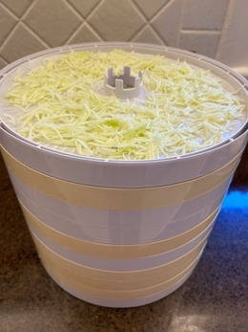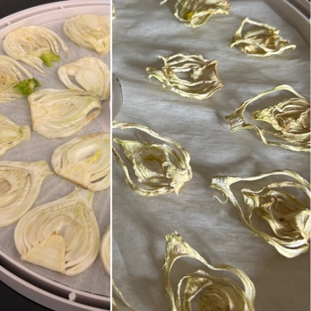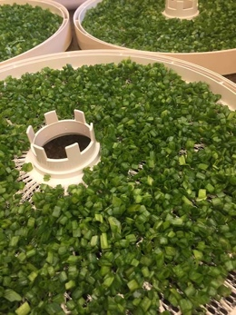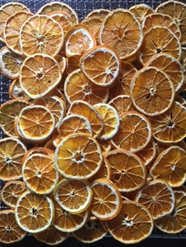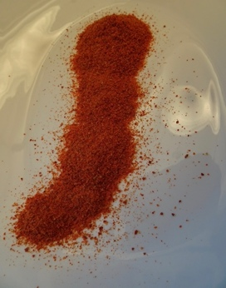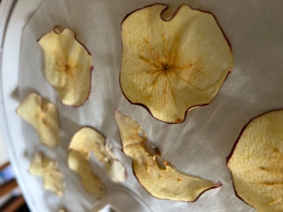

Have you been wanting to begin dehydrating the abundance of fresh produce when in season, but just not quite sure where to start?

With newfound confidence you will find your dehydrator to be your best friend almost all year round! It’s not only a simple alternative to preserve the garden’s gift, but also has you on the lookout for those bonus price reductions when you’re out shopping - and for us, a great way to deal with those bits and pieces that we know are not going to get used quickly enough (sorry to the compost!). You will be surprised at how easy the process is!

**What we will cover**

* Why dehydrate excess produce?
* What can be dehydrated?
* How to dehydrate fruit, veg and edible flowers.
* Tips and tricks.
* Storing the end product.
* How to use your dehydrated produce, including recipes that will be cooked on the day for lunch.

**Date:** Sunday 23 March 2025

**Proposed program for attendees on the day:**

9:45 am Arrive Yintarini Farm

10:00 am Welcome to Yintarini Farm with your host, Lucy.

10:10 am Dehydrating Fruit and Vegetables with Julie from SBA’s Kitchen, a hands-on session which includes cooking with dehydrated produce.

12:30 pm Lunch

1:15 pm Tour with our host, Lucy, of Yintarini Farm’s kitchen garden, featuring 12 IBC wicking beds and discussion about how these beds are sustainable and water friendly, as well as how much you can grow in a small area - half of the beds are located in their 7 metre long hot house and half are outside. (Psst, we will be using a little of the produce from this fabulous garden on the day.)

1:45 pm Prepare your own soup blend, dip blend and simmer pot bags to take home, with Julie from SBA’s Kitchen.

3:00 pm Depart Yintarini Farm

**Price:** $65.00 (incl GST & Eventbrite fees)

**Minimum no attendees to run:** 6 people

**Maximum:** 10 – 12 as advised

**Includes:**

* Extensive notes on dehydrating your own produce at home.
* Your own jar of soup blend and dip blend, as well as simmer pot bags made on the day
* Recipes for each of the dishes prepared for lunch.
* A selection of gluten free biscuits to snack on during the day
* A light lunch to showcase how to use dehydrated produce.
* All food will be gluten free

**Attendees please:**

* Advise of any dietary requirements
* Wear closed toe shoes.
* Bring an apron, if you have one

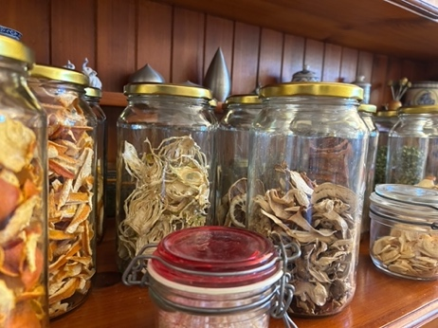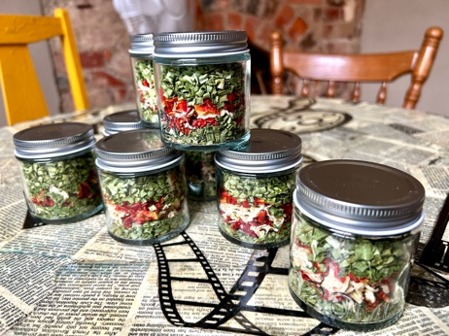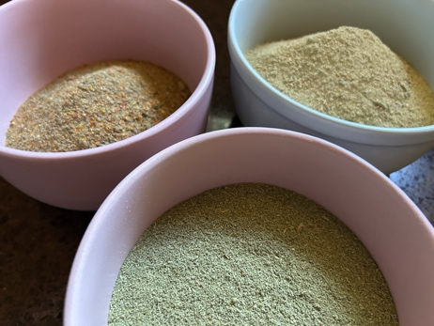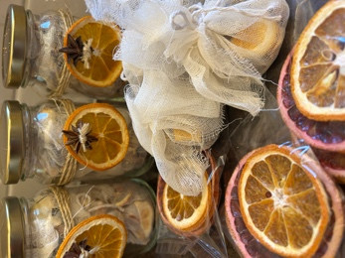

**Lunch Menu**

* Mediterranean Dip with Veg Chips
* Winter Warming Soups
* Zucchini Slice* with a Simple Green Salad
* Citrus & Zucchini Cake
* Choc Dipped Dehydrated Orange Slices with Sprinkles

**\*** contains bacon